FY 20 – XX ?
Enhanced Interim Measure Evaluation of Operational Passage in South Fork McKenzie

Management Purpose
Compare regulating outlet (RO) and turbine passage routes effects on size of run, timing, and distance attained for downstream migration of juvenile Chinook. Use results of this to inform adjustments during the current year and future years to operations in spring, fall and winter to improve passage based on timing, and successful migration from below dam to McKenzie mainstem.

Objective
As a prototype of possible more extensive study, monitor how fish migrate from above Cougar Dam through available passage routes into the reaches below Cougar Dam, the lower South Fork McKenzie and the mainstem McKenzie River. Given that operational passage options affect the size range of fish passing under different conditions, migration outside of the screwtrapping area should be monitored. Captured fish can be assigned to passage routes, and then collecting information on timing leaving the South Fork McKenzie River and approximate timing leaving the mainstem McKenzie River, will show if the route, timing, and passage operations affect size, and fractions moving or staying.

Metrics
- Numbers of juvenile Chinook estimated for each route
- Peak juvenile Chinook capture and median subyearling migration dates.
- Weekly or more frequent fish counts, with size, condition, and injuries.
- Reservoir and RO operations
  - daily data for elevation, % of flow, change in total flow, gate openings
- Timing of fish arrival downstream near confluence of mainstem, South Fork McKenzie
- Timing of fish outmigration to mainstem McKenzie River (e.g. at Walterville canal antenna, extending over months to cover the majority of outmigrants)
- Timing of any fish outmigrating to the Willamette Falls antenna

Background
Past work informing this study includes the multiyear study of McKenzie outmigrating juvenile Chinook, describing a wide variety of strategies for outmigration. Migration pulses were observed during the early first spring (fry), late first spring (subyearling), autumn, and second spring (yearling) (Schroeder et al. 2016). Also Beeman et al (2013, 2014) noted varied responses to reservoir operations and available passage routes from outplanted fish in Cougar reservoir during winter months, with the highest survival at the lowest elevations, and RO only passage route (see Table 7 and Figure 6 from Beeman et al 2014 below).

Over several years of screwtrapping above and below the dam, Romer et al (2014, 2017) estimated between 150,000 to almost 700,000 subyearlings in the river above the reservoir over 2009-2013 brood years, with notably lower numbers of outplanted spawners since that time. Juvenile tagging studies indicate poor juvenile survival through the Cougar Project (both Cougar Reservoir and Dam) (Beeman et al. 2013). The survival estimate for juvenile Chinook salmon through the reservoir and the dam was 17.5% (11.6-25%) in 2013 (Romer et al. 2014) without inclusion of delayed mortality from dam passage. At the low end of survival, the outmigrating juveniles may only number 1000 possibly caught in the screwtraps, while at the higher end, as many as 175,000 that enter the reservoir and could survive passage would be available to capture, both as subyearlings and yearlings. Many of the effects of reservoir rearing, such as copepod infection and predators, also affect the outmigration size and success.

Previous work showed most juvenile Chinook pass at night, and vary in timing over a range of RO flows, gate openings and reservoir elevations. This work will build on these earlier results to fine tune proposed actions for improved passage.

SCHEDULE: 2021-2024. An approximate 3-year study to cover a range of environmental and operational conditions. Importantly, starting in calendar year 2021 will provide data from the first year of the operations to inform upcoming decisions in following years, and ESA and EIS documents. This will also allow work below Cougar to mark and recapture fish to enhance the data collected in this study.

Point of Contact: TBD/Anne Mullan

This may go to the Cramer Fish Sciences team for FY20, with contract decisions allowing for others. Timing of downstream passage may be monitored by USFS and ODFW in addition to the work done to capture fish data and reservoir operation data by Cramer Fish Sciences.

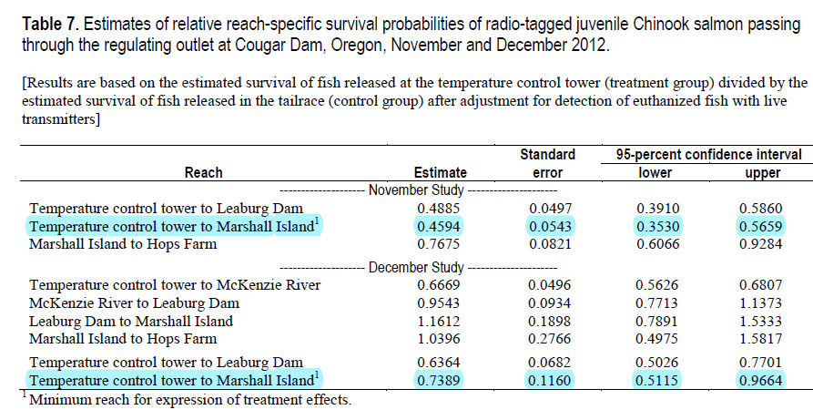
Above table of results from Beeman et al 2014, p.34.

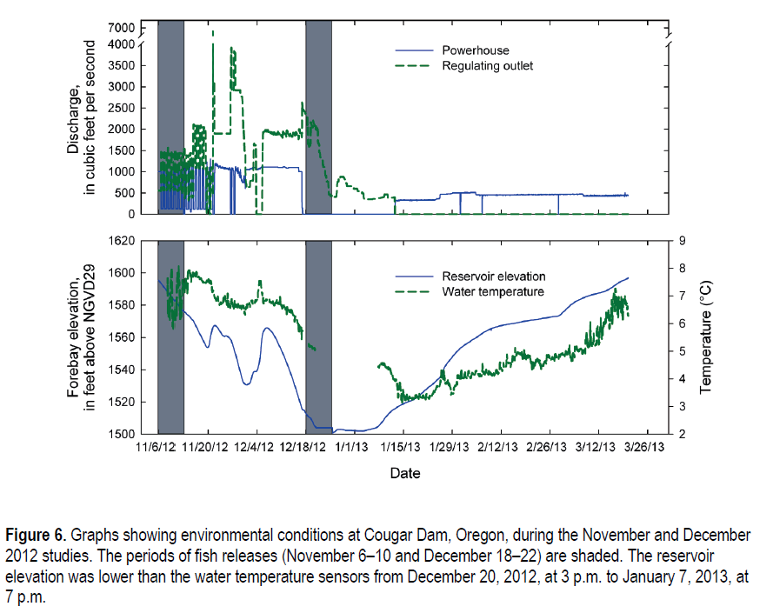
These pair of graphs, show the changes in elevation, temperature, and discharge by date, along with the split between turbine (powerhouse) and RO possible passage routes. Beeman et al 2014, p.17

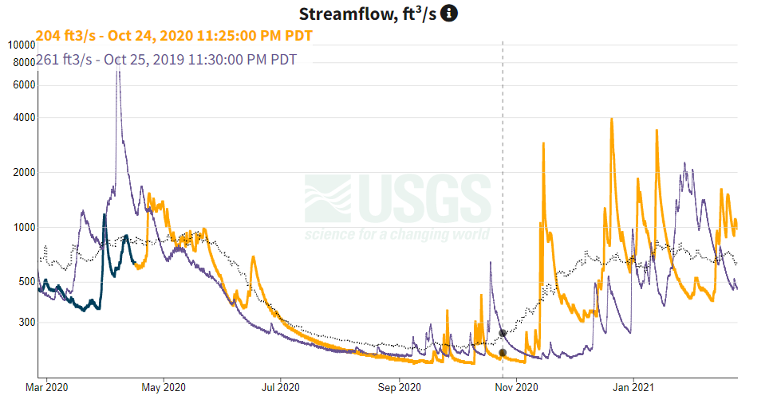

Two years of USGS streamflow data (yellow is 2020-2021, purple 2019-2020) from above Cougar show how differences of up to an order of magnitude affect the potential conditions for juvenile Chinook in the river prior to entering the reservoir. Source USGS gage 14159200

References

Beeman, J.W., H.C. Hansel, A.C. Hansen, P.V. Haner, J.M. Sprando, C.D. Smith, S.D. Evans, and T.W. Hatton. 2013, Behavior and dam passage of juvenile Chinook salmon at Cougar Reservoir and Dam, Oregon, March 2011–February 2012: U.S. Geological Survey Open-File Report 2013-1079, 48 p.

Romer, J.D., F.R. Monzyk, R. Emig, and T.A. Friesen. 2014. Juvenile salmonid outmigration monitoring at Willamette Valley project reservoirs. Task Order Number W9127N-10-2-008-0019. 61 p

Romer, J.D., F.R. Monzyk, R. Emig, and T.A. Friesen. 2017. Juvenile salmonid outmigration monitoring at Willamette Valley project reservoirs. Task Order Number W9127N-10-2-0008-0035. 49 p

Sard, N.M., D.P. Jacobson, M.J. Hogansen, K.G. O’Malley, M.A. Johnson, and M.A. Banks. 2017. Chinook salmon reintroduction above Cougar Dam: Insights from genetic parentage assignments. Presentation at the Willamette Science Review, February 8-9, 2016. Corvallis, Oregon.

Schroeder, R.K., L.D. Whitman, B, Cannon, P. Olmsted. 2016. Juvenile life-history diversity and population stability of spring Chinook salmon in the Willamette River basin, Oregon. Canadian Journal of Fisheries and Aquatic Sciences. 73:1-14.

